1 Objectives

The deliverables of a project comprise many components such as, presentations, reports, documentation, and the source code itself. Full documentation is an essential part of any project. It enables the evaluator to follow up the source of ideas, interpretations and information in the report and it makes clear how you are drawing your conclusions from the evidence presented. Failure to document adequately and fully is to ignore scholarly rules and may mean that you may not receive full recognition for your work.

We outline here the objectives that you can expect to achieve:

- Be able to design, develop, test and implement an extensive application.
- Develop professional competency in teamwork and co-ordination within a set period.
- Be able to present a software development project professionally.

2 The project consists of the following stages and deliverables:-

Stage Activity Deliverable

I System design and implementation plan Design presentation
II System partial documentation submission Partial documentation
III System development and implementation Program presentation
IV System documentation development Final documentation

In stage 1 and II of the project, you are allocated two weeks to design the system and propose an implementation plan. The partial documentation is to be presented to the project supervisor. It should include a plan of your entire workload for all stages in a Gantt chart.

In stage III of the project, you actually develop and implement the designs to produce a fully integrated application program. This stage is normally completed in six weeks and at the end of the duration, each group will give a presentation of their final product to the project supervisor.

In the final stage IV, your group will complete the full set of documentation of the project within two weeks after the program presentation.

The illustration provided below diagrammatically outlines the overall schedule, which you are required to follow.

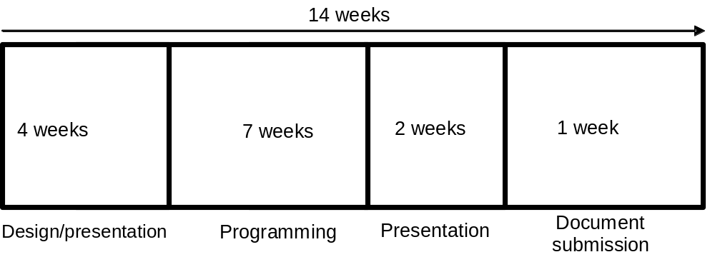

3 Documentation

Documentation should be used not only to provide the source of a direct quotation but also to give the source for any information, ideas or interpretation that you have used. To state other people's ideas as your own in the absence of proper citation is considered theft of intellectual property: Plagiarism is a serious offence within both academic circles and society, not to mention prospective employers. As such, it is subject to disciplinary action. The general guidelines for documentation are listed below.

- Your documentation should not normally exceed fifty pages, excluding diagrams, tables, coding and minutes of your meetings and discussions.
- Coding can be optionally enclosed as an appendix in your project documentation.
- You must maintain consistency throughout your work. This relates to all aspects of the development of your system. For example, consistency should be applied to areas such as the fonts (TNR 10 is recommended) used within the documentation, coding standards such as indentation, style of coding, style of designs and others.
- Be sure that each citation in the text has a corresponding reference in the reference section.
- Provide accurate and full details in the reference to enable the evaluator to locate the source of the cited document.
- Everything must be typed and printed including diagrams and tables.
- Maintain uniform indentation and spacing throughout your documentation.
- Language must be clear and without errors.

4 The project process

You will be assigned a project supervisor who will be responsible for managing the project activity as well as the occasional guidance as necessary.

- The duration of the entire project is fourteen weeks:-
Planning system design and implementation 4 weeks
System development and implementation 7 weeks
System presentation 2 weeks
Documentation development 1 week

ii) You will be doing the project in a group and this will be finalised by your project supervisor.
- You and your group are responsible for reporting to your project supervisor once a week through a weekly progress report. This report will act as the minutes of meetings held during the week. Your progress report must include the progress of your project work and any issues relating to your project. Any issues, which are uncovered in the project, must be addressed immediately.
- Any missed deadlines must be supported by an EC.
- All communication with the project supervisor must be through the group project leader.

5 Project assessment

The project is assessed on the following four deliverables:

Deliverable Proportion of total marks

Design presentation 10%
Partial documentation 25%
Program presentation 50%
Final documentation 15%

6 Documentation assessment criteria

- Overall documented standard.
- Compliance to specifications of documentation.
- The level of consistency throughout your documentation.
- The selection and use of appropriate techniques of analysis, design and implementation.

7 Partial documentation requirements

1 Introduction to the project. This section should be used to provide the reader with a brief introduction to what the whole project is all about.
2 System charts or data flow diagrams
3 Gantt Charts (schedule of activities). This chart should clearly outline the major activities involved in the project.
4 Workload matrix (outline of responsible individuals). This chart should clearly outline the activities being carried out by every individual of the project team.
5 Hierarchy Chart (outline of system modules). This chart should clearly outline the modules, which the system is to contain.
6 Pseudocode or program flowcharts (optional). This section will contain the algorithm of every program or module within each program.
7 Screens design. This section must contain the design of the screens used by the system. This should contain input screens as well as menus used within.
8 Report design. This section should contain the designs of the reports used by the system.
9 Test plan. This section should outline the test plan used to ensure that the design is correct. Data sets should also be provided to check the correctness of the design.
10 Perceived limitations. This section should outline issues, which the system is unable to address. This section should also address the issue of future enhancements.
11 Perceived assumptions. Under this section, you are required to state any assumptions, which you have identified.

8 Final documentation contents (recommended)

(There is a deliberate overlap of the final documentation with partial documentation. The partial documentation is meant to be a subset of the final documentation).
The submitted documentation should include the following sections:
  - A table of contents, which outlines the topics of the document together with the relevant page, numbers where topics are located.
  - An acknowledgement section.
  - An introduction to the project. This section should be used to provide the reader with a brief introduction to what the whole project is all about. It should also include the complete program specification provided by the project supervisor.
  - Gantt Charts (schedule of activities). This chart should clearly outline the major activities involved in the project.
  - Workload matrix (outline of individual responsibilities). This chart should clearly outline the activities being carried out by every individual of the project team.
  - Hierarchy Chart (outline of system modules). This chart should clearly outline the module which the system is to contain.
  - Pseudocode or program flowcharts. This section contains the details of the design of the system. The design should not be ambiguous but detailed.
  - Screen designs. This section must contain the design of the screens used by the system. This should contain input screens as well as menus used within.
  - Report designs. This section should contain the designs of the reports used by the system.
  - Test plans. This section should outline the test plan used to ensure that the design is correct. Data sets should also be provided to check the correctness of the design. It should also include results of tests and the conclusions.
  - Limitations and enhancements. This section should outline the issues, which the system is unable to address. It can also include the difficulty the group might have faced. This section should also address the issue of future enhancements.
  - Assumptions. Under this section, you are required to state any assumptions, which you have identified.
    - Reference section. This must use the Harvard system of referencing system.
  - Appendix (hard copy listings of programs)
  - Minutes of all meetings which have been conducted to date.
9 Project documentation
Project documentation is required to be prepared on standard A4 sized paper (210mm X 297mm). Presentation of material within the documentation should, as far as possible, be presented in the portrait form. Landscape forms are allowed mainly for illustrative documentation such as screens design or report design.

PORTRAIT

LANDSCAPE

- Paper weight should be anything equivalent to (or above) 80grams as the paper lighter than this weight tends to be very “transparent”.
- Documentation must be prepared using white coloured paper only. Ensure that the documentation is properly and professionally prepared, placing emphasis on language clarity, flow of thoughts, neatness, accurate information, useful information and general report presentation.
- The documentation is required to be bound in a hard cover form as detailed below:

Cover colour : Maroon

Size : A4

Front cover : The Logo and name 'APIIT' - centralised at top (2.5" from top edge)
: Approved title - centralised below in capitals

: Group number and group member names - at bottom right corner)
(See below)

: All lettering in gold (both front cover and side cover)
Lettering size - 0.25"
Lettering - see diagram below for upper and lower case letterings

Side Cover : Approved Title - centralised along the side
: Course and year
Format: APIIT LEVEL 1 MONTH YY F/T
: Lettering size = 0.25"
All lettering are capitalised

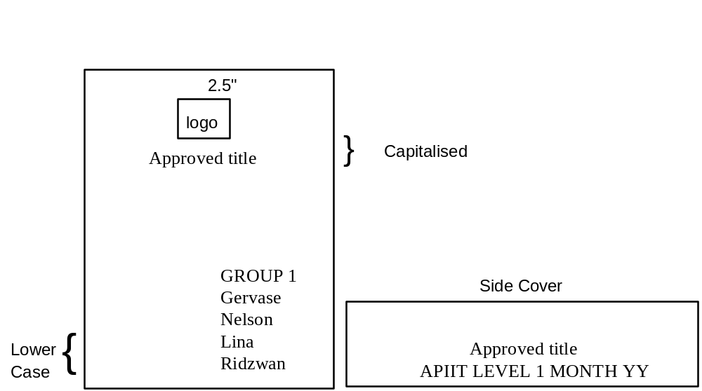

10 System design and implementation plan.

The evaluation criteria considered are-

- The overall design of your system. This should include the following details:-
  - Hierarchy Chart (outline of system modules).
  - Pseudocode or program flowcharts.
- The modularity of your system design.
- The charts and tools you have used in the design and implementation plan.

11 Here are some criteria considered in the development of your system and its implementation

- Approach to project development.
- The ability to work unsupervised.
- Readiness to accept guidance.
- The modularity of your program design.
- The ability to answer questions about the project development.

12 Oral Presentation

This will include

- Your active participation in project presentation.
- How well the presentation was conducted. This is based on factors such as the following:-
  - Communication.
  - Clarity in content.

13 Weekly reports

This includes:-

- Punctual submission of weekly reports to your project supervisor. You will be submitting your report from the first week of your project at least until the 8th week.
- Contents of your weekly report. The contents of the weekly report should, at least contain the following details:
  - A general one page description on the progress of the project work.
  - Any issues relating to project work.
  - Minutes of your group discussion, which should outline positive decisions being made and problems being solved.
  - Scheduled workload of all group members.
- All weekly progress reports should be accompanied with a standard front page. This front page should contain the relevant details, which identifies the group submitting the report. The weekly reports, as they normally consist of a few pages, can be staple bound. Please refer to the example shown below for the format.
Group Number
:
One
Project Title
:
Date of Report
:
dd/mm/yyyy
Intake Code
:
DFxxxx
xxxxxxxxxxxxxxxx
xxxxxxxxxxxxxxxx
xxxxxxxx
Week Number
:
One
Programming Project
Weekly Report

14 Reading list

Software System Development, 3rd Ed., 2003
Carol Britton and Jill Doake
McGraw Hill Education

An Introduction to Program Design, 1991
D Sargent
McGraw-Hill International Editions

CASE METHOD
Entity Relationship Modelling, 1990
Richard Barker
Addison-Wesley Publishing Company

Principles of Program Design, 1975
M.A. Jackson
Academic Press

Systems Analysis and Design Methods, 4th Ed., 1997
Whitten et. al.
IRWIN

Simple Program Design, 2nd Ed., 2003
Leslie Ann Robertson
Boyd & Fraser

EC: Extenuating circumstance.
MONTH should spell the actual month in capitals. E.g., MARCH.
YY should be the last 2 digits of the year. E.g., 2006 should be 06.

